How to remove a portfolio from a local electronic collection | 

ONE
Local Collection ‘Project Gutenberg Free E Books’ has 16 portfolios.
We want to remove title “Why Worry” from the collection.
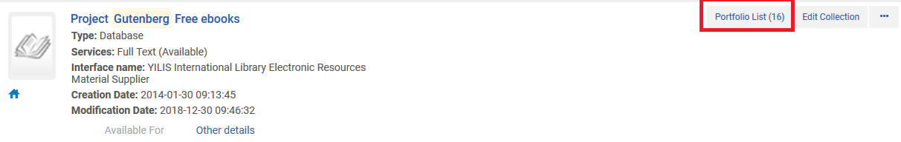

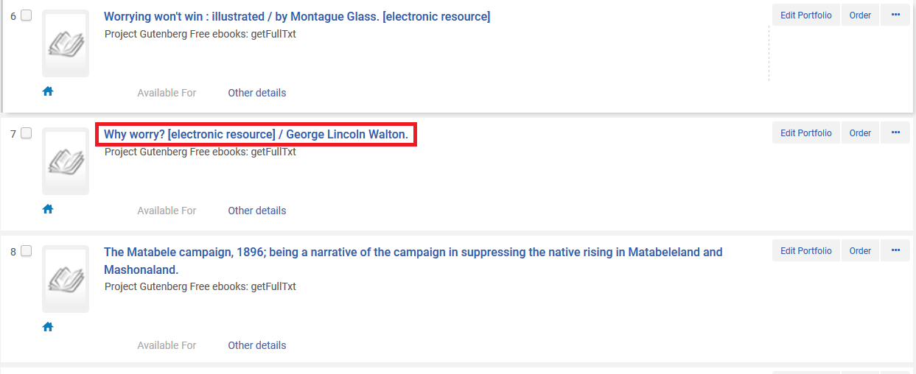

TWO
From the electronic collection repository search results click “edit service” and then switch to the “portfolios” tab.
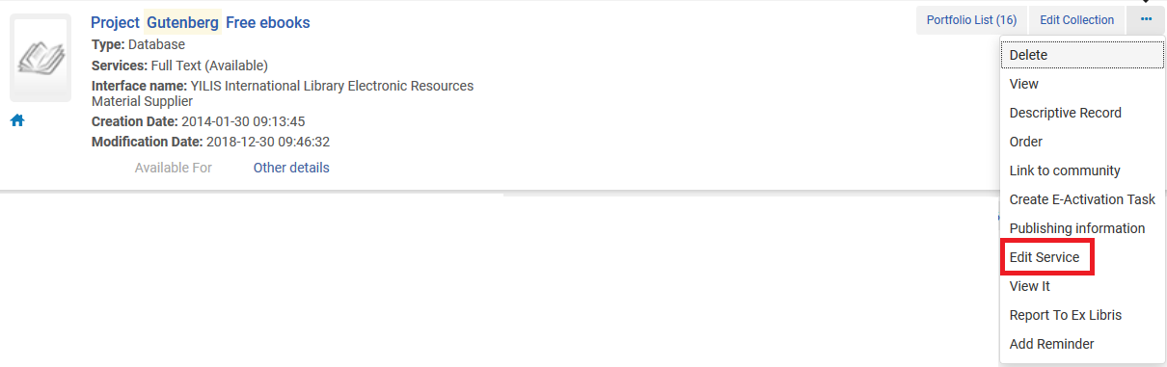

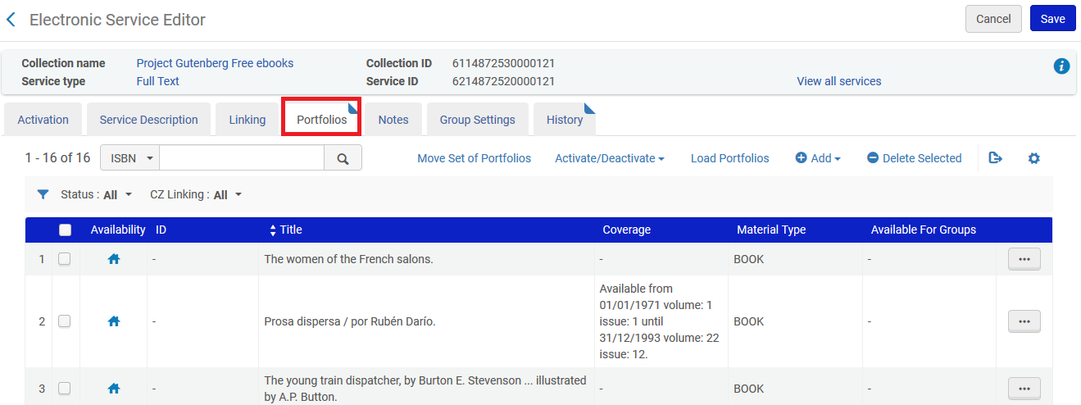
THREE
Find the title you want to remove and then click “actions > remove”. You will receive confirmation that the portfolio has been removed.

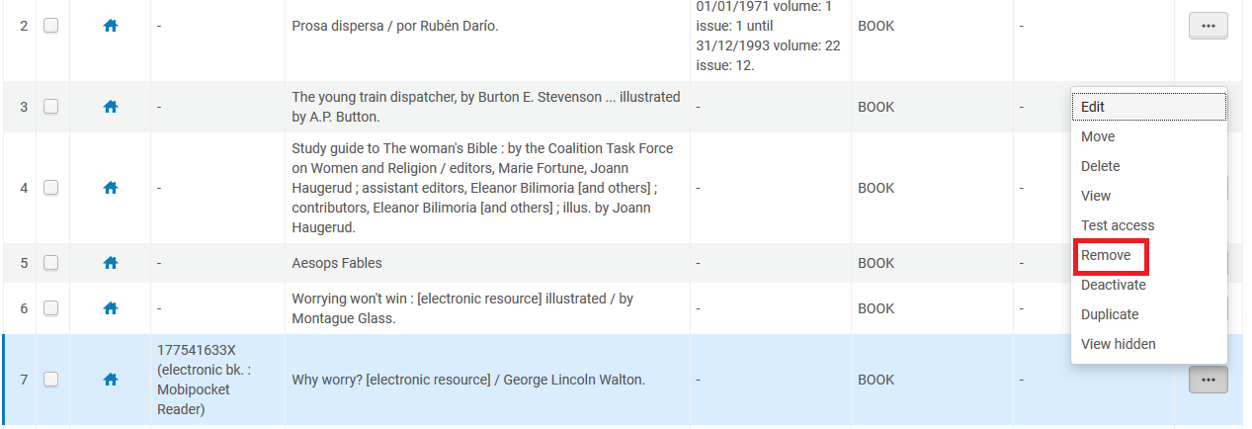

FOUR

Now you will see that the electronic collection has one less portfolio.
Previously there were 16 portfolios, now there are 15.

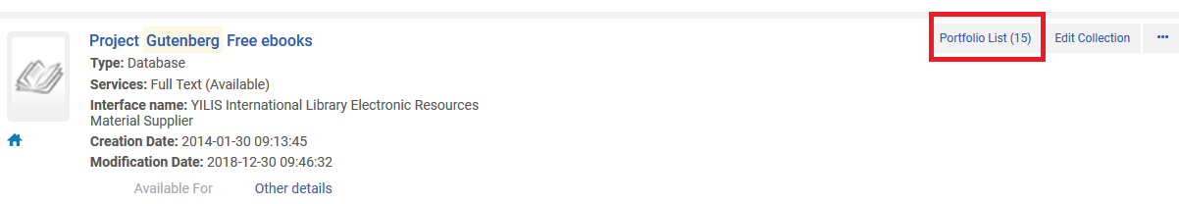

You will also see that the bibliographic record and portfolio still exist for the title which was removed from the collection. It is now a standalone portfolio.



